**Helm 2 vs Helm 3 Architecture**

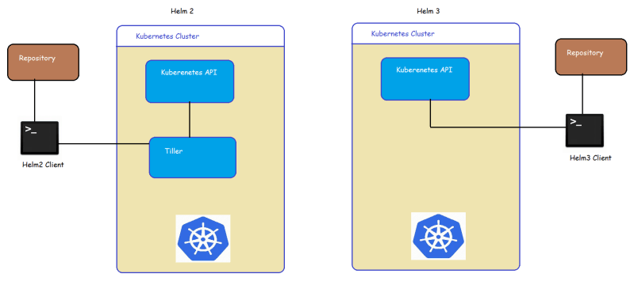

* Helm and k8s work like a client/server application.
* Helm client pushes the resources to the k8s cluster.
* In Helm 2 the server-side depends on the Tiller whereas Helm 3 got rid of Tiller and entirely relies on Kubernetes API
* Helm 3 authenticates and authorizes by taking the credentials kubectl

**Quick YAML Refresher**

* Multi line string

configurations: |

server.port=8443

logging.file.path=/var/log

**Helm Chart Structure**

* When we create a helm chart the directory structure will be as shown below 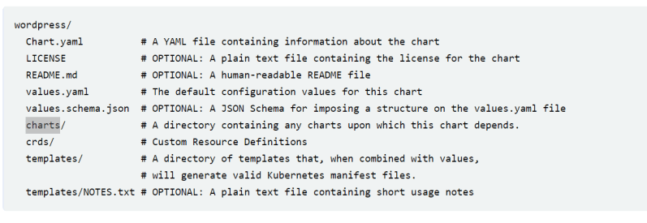
* Now let’s try to understand the purpose of file/directory in the helm charts

| **File/directory** | **Definition** | **Required** |
| --- | --- | --- |
| Chart.yaml | This file contains metadata about Helm chart | Yes |
| templates/ | This directory contains K8s resources in YAML Format | Yes, unless dependencies are declared in Chart.yaml |
| template/NOTES.txt | A file that can be generated to provide usage instructions during chat installtions | No |
| values.yaml | This file contains the charts default values | No, but every chart should contain this file as a best practice |
| .helmignore | A file that consists of list of files and directories that should be ommited from Helm Charts packaging | No |
| charts/ | This directory contains charts that the current Helm Chart depends on | Does not need to be explicitly provided as Helm’s dependency management system will automatically create this directory |
| Chart.lock | A file used to save the previously applied dependency version | Does not need to be explicitly provided as Helm’s dependency management system will automatically create this directory |
| crds/ | A directory that contains Custom Resource Definition YAML resources to be installed before templates | No |
| README.md | A file that contains installation & usage information about Helm Chart | No, but every chart should contain this file as a best practice |
| LICENSE | A file that contains HELM charts LICENSE | No |
| values.schema.json | A file that contains the chart’s value schema in JSON format | No |

* Lets create a dummy chart

helm create --help

helm create helloworld

Creating Helm chart:

For a typical cloud-native application with a 3-tier architecture, the diagram below illustrates how it might be described in terms of [Kubernetes objects](http://kubernetes.io/docs/concepts/overview/working-with-objects/kubernetes-objects/). In this example, each tier consists of a [Deployment](http://kubernetes.io/docs/user-guide/deployments/) and [Service](http://kubernetes.io/docs/user-guide/services/) object, and may additionally define [ConfigMap](http://kubernetes.io/docs/user-guide/configmap/) or [Secret](http://kubernetes.io/docs/user-guide/secrets/) objects. Each of these objects are typically defined in separate YAML files, and are fed into the kubectl command line tool.

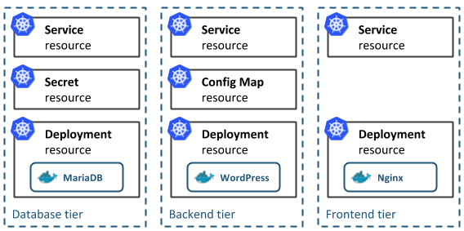

A Helm chart encapsulates each of these YAML definitions, provides a mechanism for configuration at deploy-time and allows you to define metadata and documentation that might be useful when sharing the package. Helm can be useful in different scenarios:

* Find and use popular software packaged as Kubernetes charts
* Share your own applications as Kubernetes charts
* Create reproducible builds of your Kubernetes applications
* Intelligently manage your Kubernetes object definitions
* Manage releases of Helm packages

Let's explore the second and third scenarios by creating our first chart.

# Step 1: Generate your first chart

The best way to get started with a new chart is to use the helm create command to scaffold out an example we can build on. Use this command to create a new chart named mychart in a new directory:

helm create mychart

Helm will create a new directory in your project called mychart with the structure shown below. Let's navigate our new chart (pun intended) to find out how it works.

mychart

|-- Chart.yaml

|-- charts

|-- templates

| |-- NOTES.txt

| |-- _helpers.tpl

| |-- deployment.yaml

| |-- ingress.yaml

| `-- service.yaml

`-- values.yaml

## Templates

The most important piece of the puzzle is the templates/ directory. This is where Helm finds the YAML definitions for your Services, Deployments and other Kubernetes objects. If you already have definitions for your application, all you need to do is replace the generated YAML files for your own. What you end up with is a working chart that can be deployed using the helm install command.

It's worth noting however, that the directory is named templates, and Helm runs each file in this directory through a [Go template](https://golang.org/pkg/text/template/) rendering engine. Helm extends the template language, adding a number of utility functions for writing charts. Open the service.yaml file to see what this looks like:

apiVersion: v1

kind: Service

metadata:

name: {{ template "fullname" . }}

labels:

chart: "{{ .Chart.Name }}-{{ .Chart.Version | replace "+" "_" }}"

spec:

type: {{ .Values.service.type }}

ports:

- port: {{ .Values.service.externalPort }}

targetPort: {{ .Values.service.internalPort }}

protocol: TCP

name: {{ .Values.service.name }}

selector:

app: {{ template "fullname" . }}

This is a basic Service definition using templating. When deploying the chart, Helm will generate a definition that will look a lot more like a valid Service. We can do a dry-run of a helm install and enable debug to inspect the generated definitions:

helm install --dry-run --debug ./mychart

...

# Source: mychart/templates/service.yaml

apiVersion: v1

kind: Service

metadata:

name: pouring-puma-mychart

labels:

chart: "mychart-0.1.0"

spec:

type: ClusterIP

ports:

- port: 80

targetPort: 80

protocol: TCP

name: nginx

selector:

app: pouring-puma-mychart

...

### Values

The template in service.yaml makes use of the Helm-specific objects .Chart and .Values.. The former provides metadata about the chart to your definitions such as the name, or version. The latter .Values object is a key element of Helm charts, used to expose configuration that can be set at the time of deployment. The defaults for this object are defined in the values.yaml file. Try changing the default value for service.internalPort and execute another dry-run, you should find that the targetPort in the Service and the containerPort in the Deployment changes. The service.internalPort value is used here to ensure that the Service and Deployment objects work together correctly. The use of templating can greatly reduce boilerplate and simplify your definitions.

If a user of your chart wanted to change the default configuration, they could provide overrides directly on the command-line:

helm install --dry-run --debug ./mychart --set service.internalPort=8080

For more advanced configuration, a user can specify a YAML file containing overrides with the --values option.

### Helpers and other functions

The service.yaml template also makes use of partials defined in _helpers.tpl, as well as functions like replace. The [Helm documentation](https://helm.sh/docs/chart_template_guide/getting_started/) has a deeper walkthrough of the templating language, explaining how functions, partials and flow control can be used when developing your chart.

## Documentation

Another useful file in the templates/ directory is the NOTES.txt file. This is a templated, plaintext file that gets printed out after the chart is successfully deployed. As we'll see when we deploy our first chart, this is a useful place to briefly describe the next steps for using a chart. Since NOTES.txt is run through the template engine, you can use templating to print out working commands for obtaining an IP address, or getting a password from a Secret object.

## Metadata

As mentioned earlier, a Helm chart consists of metadata that is used to help describe what the application is, define constraints on the minimum required Kubernetes and/or Helm version and manage the version of your chart. All of this metadata lives in the Chart.yaml file. The [Helm documentation](https://helm.sh/docs/) describes the different fields for this file.

# Step 2: Deploy your first chart

The chart you generated in the previous step is set up to run an NGINX server exposed via a Kubernetes Service. By default, the chart will create a ClusterIP type Service, so NGINX will only be exposed internally in the cluster. To access it externally, we'll use the NodePort type instead. We can also set the name of the Helm release so we can easily refer back to it. Let's go ahead and deploy our NGINX chart using the helm install command:

helm install example ./mychart --set service.type=NodePort

NAME: example

LAST DEPLOYED: Tue May 2 20:03:27 2017

NAMESPACE: default

STATUS: DEPLOYED

RESOURCES:

==> v1/Service

NAME CLUSTER-IP EXTERNAL-IP PORT(S) AGE

example-mychart 10.0.0.24 <nodes> 80:30630/TCP 0s

==> v1beta1/Deployment

NAME DESIRED CURRENT UP-TO-DATE AVAILABLE AGE

example-mychart 1 1 1 0 0s

NOTES:

1. Get the application URL by running these commands:

export NODE_PORT=$(kubectl get --namespace default -o jsonpath="{.spec.ports[0].nodePort}" services example-mychart)

export NODE_IP=$(kubectl get nodes --namespace default -o jsonpath="{.items[0].status.addresses[0].address}")

echo http://$NODE_IP:$NODE_PORT/

The output of helm install displays a handy summary of the state of the release, what objects were created, and the rendered NOTES.txt file to explain what to do next. Run the commands in the output to get a URL to access the NGINX service and pull it up in your browser.

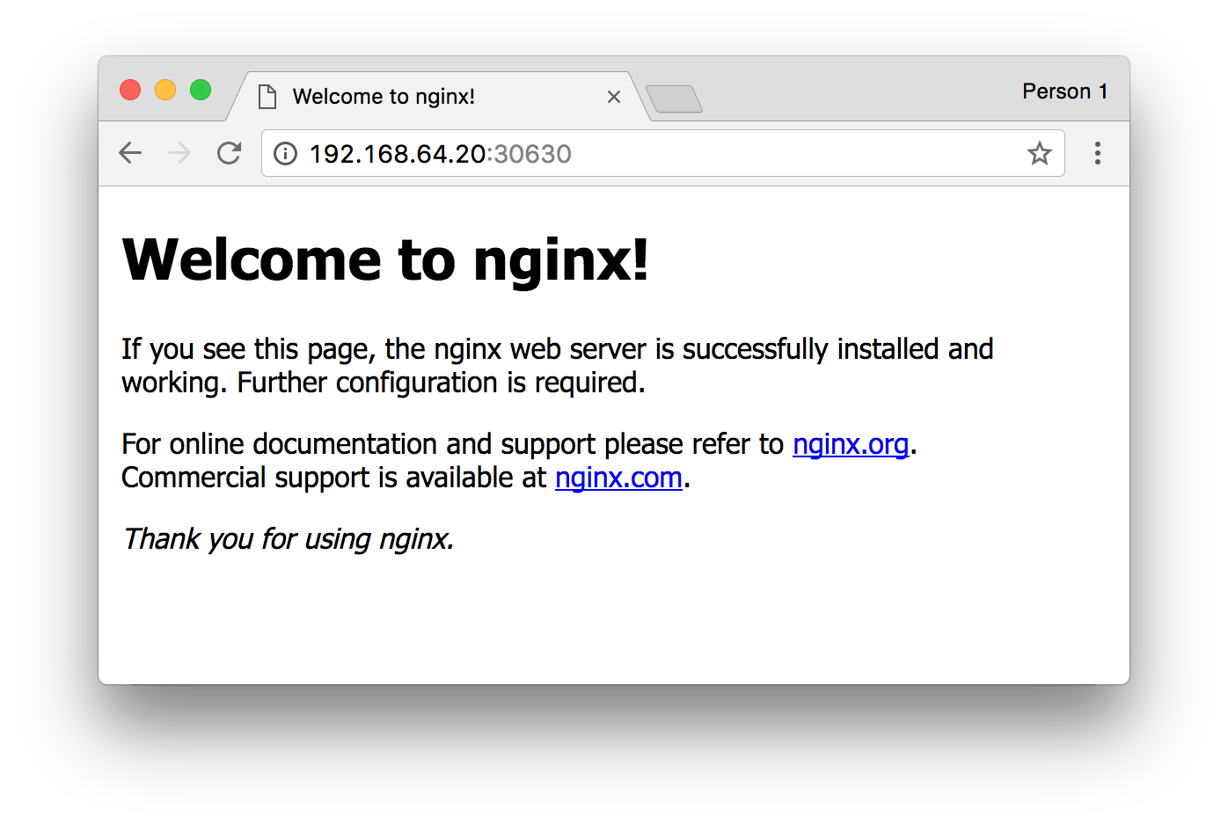

If all went well, you should see the NGINX welcome page as shown above. Congratulations! You've just deployed your very first service packaged as a Helm chart!

# Step 3: Modify chart to deploy a custom service

The generated chart creates a Deployment object designed to run an image provided by the default values. This means all we need to do to run a different service is to change the referenced image in values.yaml.

We are going to update the chart to run a [todo list application](https://github.com/prydonius/todomvc/tree/master/examples/react) available on [Docker Hub](https://hub.docker.com/r/prydonius/todo/). In values.yaml, update the image keys to reference the todo list image:

image:

repository: prydonius/todo

tag: 1.0.0

pullPolicy: IfNotPresent

As you develop your chart, it's a good idea to run it through the linter to ensure you're following best practices and that your templates are well-formed. Run the helm lint command to see the linter in action:

helm lint ./mychart

==> Linting ./mychart

[INFO] Chart.yaml: icon is recommended

1 chart(s) linted, no failures

The linter didn't complain about any major issues with the chart, so we're good to go. However, as an example, here is what the linter might output if you managed to get something wrong:

echo "malformed" > mychart/values.yaml

helm lint ./mychart

==> Linting mychart

[INFO] Chart.yaml: icon is recommended

[ERROR] values.yaml: unable to parse YAML

error converting YAML to JSON: yaml: line 34: could not find expected ':'

Error: 1 chart(s) linted, 1 chart(s) failed

This time, the linter tells us that it was unable to parse my values.yaml file correctly. With the line number hint, we can easily find the fix the bug we introduced.

Now that the chart is once again valid, run helm install again to deploy the todo list application:

helm install example2 ./mychart --set service.type=NodePort

NAME: example2

LAST DEPLOYED: Wed May 3 12:10:03 2017

NAMESPACE: default

STATUS: DEPLOYED

RESOURCES:

==> v1/Service

NAME CLUSTER-IP EXTERNAL-IP PORT(S) AGE

example2-mychart 10.0.0.78 <nodes> 80:31381/TCP 0s

==> apps/v1/Deployment

NAME DESIRED CURRENT UP-TO-DATE AVAILABLE AGE

example2-mychart 1 1 1 0 0s

NOTES:

1. Get the application URL by running these commands:

export NODE_PORT=$(kubectl get --namespace default -o jsonpath="{.spec.ports[0].nodePort}" services example2-mychart)

export NODE_IP=$(kubectl get nodes --namespace default -o jsonpath="{.items[0].status.addresses[0].address}")

echo http://$NODE_IP:$NODE_PORT/

Once again, we can run the commands in the NOTES to get a URL to access our application.

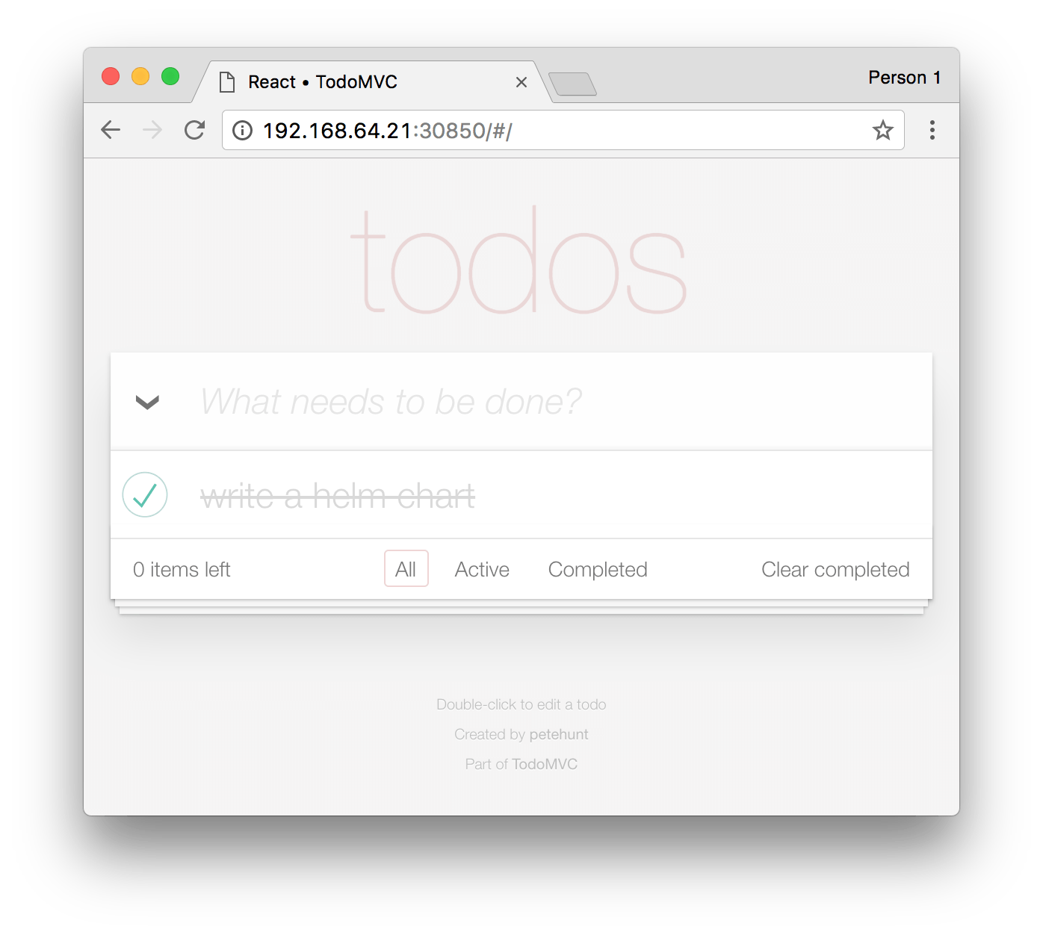

If you have already built containers for your applications, you can run them with your chart by updating the default values or the Deployment template. Check out the Bitnami Docs for an [introduction to containerizing your applications](https://docs.bitnami.com/tutorials/deploy-custom-nodejs-app-bitnami-containers/).

# Step 4: Package it all up to share

So far in this tutorial, we've been using the helm install command to install a local, unpacked chart. However, if you are looking to share your charts with your team or the community, your consumers will typically install the charts from a tar package. We can use helm package to create the tar package:

helm package ./mychart

Helm will create a mychart-0.1.0.tgz package in our working directory, using the name and version from the metadata defined in the Chart.yaml file. A user can install from this package instead of a local directory by passing the package as the parameter to helm install.

helm install example3 mychart-0.1.0.tgz --set service.type=NodePort

## Repositories

In order to make it much easier to share packages, Helm has built-in support for installing packages from an HTTP server. Helm reads a repository index hosted on the server which describes what chart packages are available and where they are located.

We can use the helm serve command to run a local repository to serve our chart.

helm serve

Regenerating index. This may take a moment.

Now serving you on 127.0.0.1:8879

Now, in a separate terminal window, you should be able to see your chart in the local repository and install it from there:

helm search local

NAME VERSION DESCRIPTION

local/mychart 0.1.0 A Helm chart for Kubernetes

helm install example4 local/mychart --set service.type=NodePort

To set up a remote repository you can follow the guide in the [Helm documentation](https://github.com/kubernetes/helm/blob/master/docs/chart_repository.md).

# Dependencies

As the applications your packaging as charts increase in complexity, you might find you need to pull in a dependency such as a database. Helm allows you to specify sub-charts that will be created as part of the same release. To define a dependency, create a requirements.yaml file in the chart root directory:

cat > ./mychart/requirements.yaml <<EOF

dependencies:

- name: mariadb

version: 0.6.0

repository: https://charts.helm.sh/stable

EOF

Much like a runtime language dependency file (such as Python's requirements.txt), the requirements.yaml file allows you to manage your chart's dependencies and their versions. When updating dependencies, a lockfile is generated so that subsequent fetching of dependencies use a known, working version. Run the following command to pull in the MariaDB dependency we defined:

helm dep update ./mychart

Hang tight while we grab the latest from your chart repositories...

...Unable to get an update from the "local" chart repository (http://127.0.0.1:8879/charts):

Get http://127.0.0.1:8879/charts/index.yaml: dial tcp 127.0.0.1:8879: getsockopt: connection refused

...Successfully got an update from the "bitnami" chart repository

...Successfully got an update from the "incubator" chart repository

Update Complete. *Happy Helming!*

Saving 1 charts

Downloading mariadb from repo

$ ls ./mychart/charts

mariadb-0.6.0.tgz

Helm has found a matching version in the bitnami repository and has fetched it into my chart's sub-chart directory. Now when we go and install the chart, we'll see that MariaDB's objects are created too:

helm install example5 ./mychart --set service.type=NodePort

NAME: example5

LAST DEPLOYED: Wed May 3 16:28:18 2017

NAMESPACE: default

STATUS: DEPLOYED

RESOURCES:

==> v1/Secret

NAME TYPE DATA AGE

example5-mariadb Opaque 2 1s

==> v1/ConfigMap

NAME DATA AGE

example5-mariadb 1 1s

==> v1/PersistentVolumeClaim

NAME STATUS VOLUME CAPACITY ACCESSMODES AGE

example5-mariadb Bound pvc-229f9ed6-3015-11e7-945a-66fc987ccf32 8Gi RWO 1s

==> v1/Service

NAME CLUSTER-IP EXTERNAL-IP PORT(S) AGE

example5-mychart 10.0.0.144 <nodes> 80:30896/TCP 1s

example5-mariadb 10.0.0.108 <none> 3306/TCP 1s

==> apps/v1/Deployment

NAME DESIRED CURRENT UP-TO-DATE AVAILABLE AGE

example5-mariadb 1 1 1 0 1s

example5-mychart 1 1 1 0 1s

NOTES:

1. Get the application URL by running these commands:

export NODE_PORT=$(kubectl get --namespace default -o jsonpath="{.spec.ports[0].nodePort}" services example5-mychart)

export NODE_IP=$(kubectl get nodes --namespace default -o jsonpath="{.items[0].status.addresses[0].address}")

echo http://$NODE_IP:$NODE_PORT/

# Contribute to the Bitnami repository!

As a chart author, you can help to build out Bitnami's chart repository by improving existing charts or submitting new ones. Checkout <https://kubeapps.com> to see what's currently available and head to <https://github.com/bitnami/charts> to get involved.

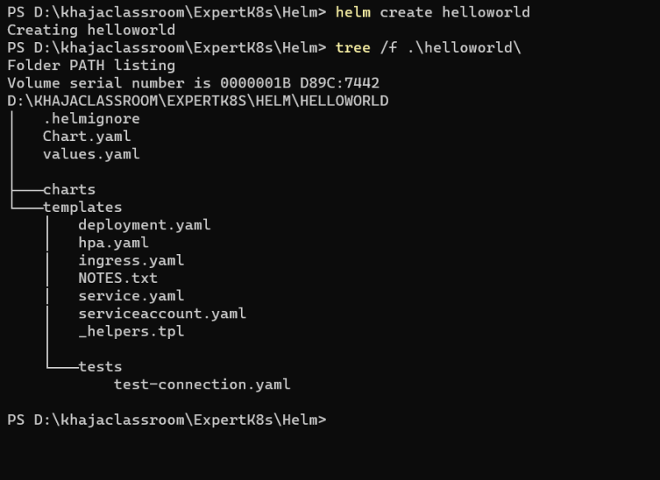

Helm 2 VS helm 3:

Helm 2 has additional component call tiller which provide release management feature, but because of its ability to modify/create and update cluster, we need to remove it, as it was causing security concern.